
LjunggrenAudio RYO Penta
a compact 4hp 5 step sequencer

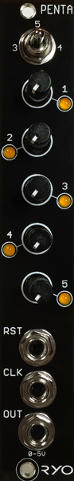

- compact 5 step sequencer.
- great for anything where a repeating stepped modulation is wanted for adding movement to sounds.
- 5 minishaft potentiometers for adjusting the 5 steps voltages, ranging from 0 to +5V.
- pattern length switch for selecting 3, 4 or 5 steps.
- All analogue circuitry.
- schmitt triggers on inputs and buffered output.
- slim 4HP footprint.
- compact 39mm Depth (with power cable attached).
- low power draw: 6mA +12V / 1mA -12V / 0mA +5V.
- Fast responding CV inputs allow for clocking up to audio rate.

downloads
* user manual
* quickstart guide
* assembly guide
* hi-res schematic
* datasheet
* BOM

